**ASSIGNMENT – 2**

NAME: G. SRIVALLI

REG NO:192365014

COURSE CODE: CSA0678

COURSE NAME: DAA [DESIGN AND ANALYSIS OF ALGORITHM]

# 11. Container With Most Water

You are given an integer array height of length n. There are n vertical lines drawn such that the two endpoints of the ith line are (i, 0) and (i, height[i]).

Find two lines that together with the x-axis form a container, such that the container contains the most water.

Return *the maximum amount of water a container can store*. Notice that you may not slant the container.

CODE:

def maxArea(A, Len) :

area = 0 for i in range(Len) :

for j in range (i + 1, Len) :

area = max(area, min(A[j], A[i]) * (j - i)) return area

a = [ 1, 5, 4, 3 ]

b = [ 3, 1, 2, 4, 5 ]

len1 = len(a) print(maxArea(a, len1)) len2 = len(b) print(maxArea(b,len2))

OUTPUT:

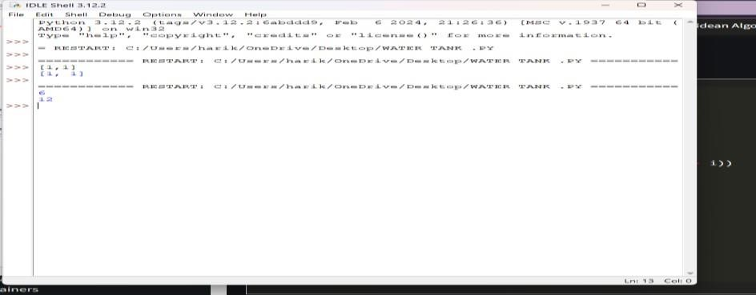

12. Roman numerals are represented by seven different symbols: I, V, X, L, C, D and

M.

Symbol Value

I 1

V 5

X 10

L 50

1. 100
2. 500

M 1000

For example, 2 is written as II in Roman numeral, just two one's added together. 12 is written as

XII, which is simply X + II. The number 27 is written as XXVII, which is XX + V + II. Roman numerals are usually written largest to smallest from left to right. However, the numeral

for four is not IIII. Instead, the number four is written as IV. Because the one is before the five

we subtract it making four. The same principle applies to the number nine, which is written as

IX. There are six instances where subtraction is used:

* I can be placed before V (5) and X (10) to make 4 and 9.
* X can be placed before L (50) and C (100) to make 40 and 90. ● C can be placed before D (500) and M (1000) to make 400 and 900. Given an integer, convert it to a roman numeral.

CODE:

def value(r): if (r == 'I'): return 1

if (r == 'V'):

return 5

if (r =='X'):

return 10

if (r == 'L'): return 50

if (r =='C'): return 100 if (r == 'D'): return 500 if (r =='M'): return 1000

else:

return -1 def romanToDecimal(str):

res = 0 i = 0 while (i < len(str)): # Getting value of symbol s[i] s1 = value(str[i]) if (i + 1 < len(str)): # Getting value of symbol s[i + 1] s2 = value(str[i + 1]) # Comparing both values if (s1 >= s2):

res = res + s1

i = i + 1

else:

res = res + s2 - s1 i = i + 2

else: res = res + s1 i = i + 1

return res

print("Integer form of Roman Numeral is"), print(romanToDecimal("MCMIV")) OUTPUT:

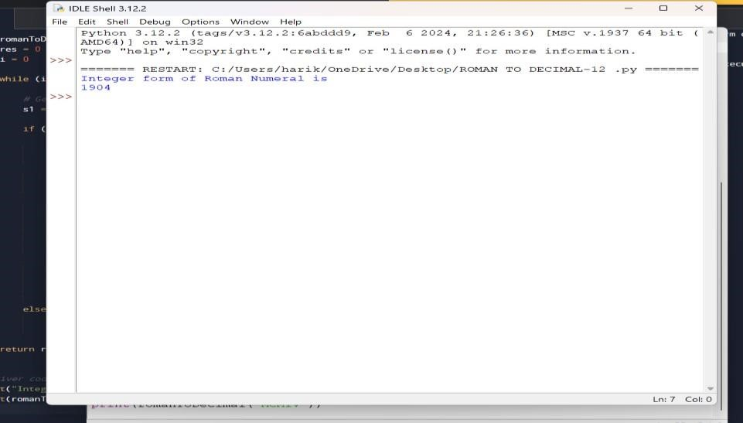

# 13. Roman to Integer

Roman numerals are represented by seven different symbols: I, V, X, L, C, D and M.

Symbol Value

I 1

V 5

X 10

L 50

1. 100
2. 500

M 1000

For example, 2 is written as II in Roman numeral, just two ones added together. 12 is written as

XII, which is simply X + II. The number 27 is written as XXVII, which is XX + V + II. Roman numerals are usually written largest to smallest from left to right. However, the numeral

for four is not IIII. Instead, the number four is written as IV. Because the one is before the five

we subtract it making four. The same principle applies to the number nine, which is written as

IX. There are six instances where subtraction is used:

* I can be placed before V (5) and X (10) to make 4 and 9.
* X can be placed before L (50) and C (100) to make 40 and 90.
* C can be placed before D (500) and M (1000) to make 400 and 900.

Code:

roman = {'I':1,'V':5,'X':10,'L':50,'C':100,'D':500,'M':1000} class Solution: def romanToInt(self, S: str) -> int:

sum= 0

for i in range(len(S)-1,-1,-1):

num = roman[S[i]] if 3*num < sum: summ = sum-num else:

summ = sum+num

return sum

OUTPUT:

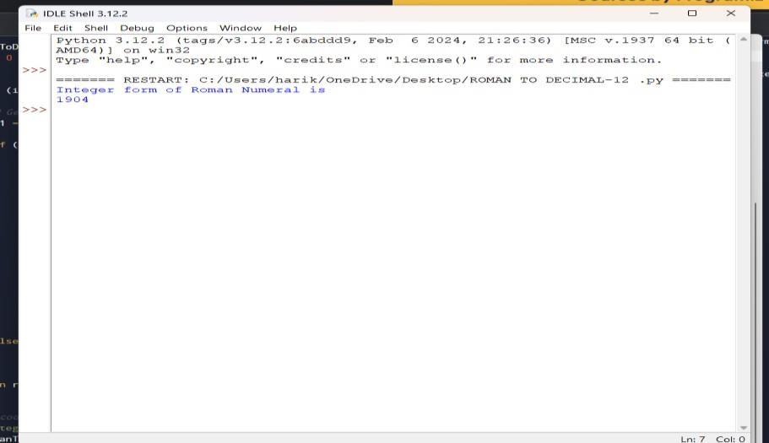

14. Longest Common Prefix

Write a function to find the longest common prefix string amongst an array of strings. If there is no common prefix, return an empty string ""

CODE:

def longestCommonPrefix( a): size = len(a)

if (size == 0):

return ""

if (size == 1):

return a[0]

min(len(a[0]), len(a[size - 1]))

i = 0 while (i < end and a[0][i] == a[size - 1][i]): i += 1

pre = a[0][0: i] return pre

if name == " main ":

input = ["geeksforgeeks", "geeks",

"geek", "geezer"]

print("The longest Common Prefix is :" , longestCommonPrefix(inp)

OUTPUT:

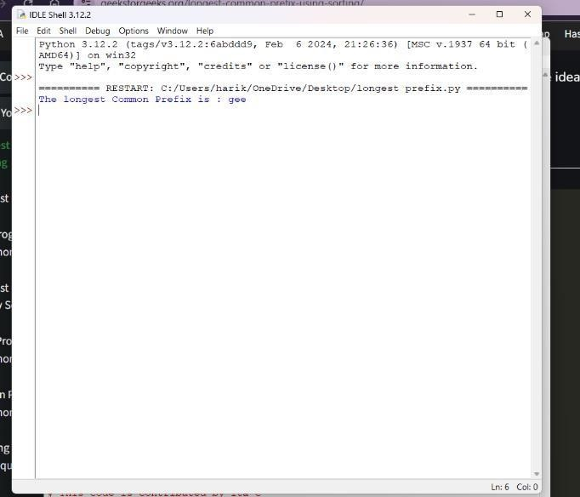

15. 3Sum

Given an integer array nums, return all the triplets [nums[i], nums[j], nums[k]] such that i != j, i

!= k, and j != k, and nums[i] + nums[j] + nums[k] == 0. Notice that the solution set must not contain duplicate triplets.

Example 1:

Input: nums = [-1,0,1,2,-1,-4]

Output: [[-1,-1,2],[-1,0,1]] Explanation:

nums[0] + nums[1] + nums[2] = (-1) + 0 + 1 = 0. nums[1] + nums[2] + nums[4] = 0 + 1 + (-1) = 0. nums[0] + nums[3] + nums[4] = (-1) + 2 + (-1) = 0.

The distinct triplets are [-1,0,1] and [-1,-1,2].

Notice that the order of the output and the order of the triplets does not matter.

CODE: def findTriplets(nums, n, Sum):

i = 0 j = 0 k = 0

. triplet = []

uniqTriplets = []

temp = ""

newTriplet = [0, 0, 0]

array. nums.sort()

for i in range(n - 2):

j = i + 1 # index of the last element. k = n - 1

while(j < k):

if(nums[i] + nums[j] + nums[k] == Sum):

temp = str(nums[i]) + ":" + str(nums[j]) + ":" + str(nums[k]) if temp not in uniqTriplets: uniqTriplets.append(temp) newTriplet[0] = nums[i] newTriplet[1] = nums[j] newTriplet[2] = nums[k] triplet.append(newTriplet) newTriplet = [0, 0, 0]

j += 1 k -= 1

elif(nums[i] + nums[j] + nums[k] > Sum): k-= 1

else:

j += 1

if(len(triplet) == 0): return 0

for i in range(len(triplet)): print(triplet[i], end = ", ") return 1

nums = [12, 3, 6, 1, 6, 9] n = len(nums) Sum = 24

if(not findTriplets(nums, n, Sum)): print("No triplets can be formed.") output:

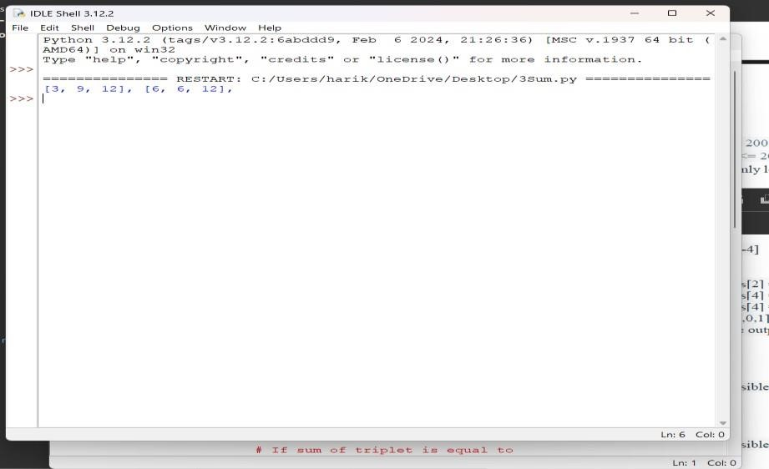

# 16. 3Sum Closest

Given an integer array nums of length n and an integer target, find three integers in nums such that the sum is closest to target.

Return *the sum of the three integers*.

You may assume that each input would have exactly one solution.

CODE:

import sys

def solution(arr, x):

closestSum = sys.maxsize

for i in range (len(arr)) :

for j in range(i + 1, len(arr)): for k in range(j + 1, len( arr)):

if(abs(x - closestSum) > abs(x - (arr[i] + arr[j] + arr[k]))): closestSum = (arr[i] + arr[j] + arr[k])

return closestSum

if name == " main ":

arr = [ -1, 2, 1, -4 ]

x = 1

print(solution(arr,x))

output:

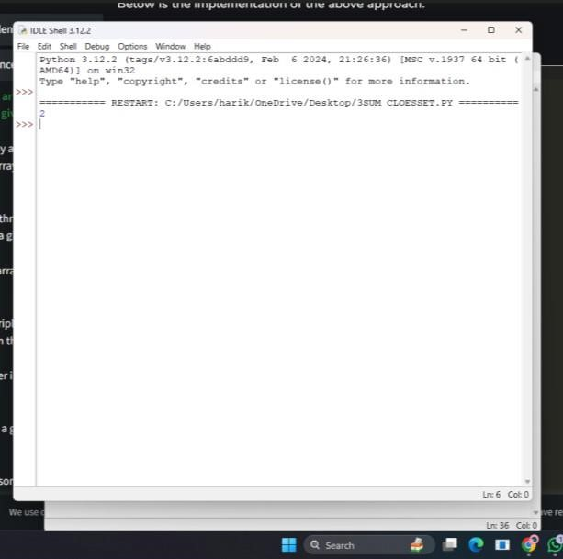

# 17. Letter Combinations of a Phone Number

Given a string containing digits from 2-9 inclusive, return all possible letter combinations that the number could represent. Return the answer in any order.

A mapping of digits to letters (just like on the telephone buttons) is given below. Note that 1

does not map to any letters.

CODE:

import deque

def letterCombinationsUtil(number, n, table):

list = [] q = deque()

q.append("")

while len(q) != 0:

s = q.pop()

len(s) == n:

list.append(s)

else:

for letter in table[number[len(s)]]:

q.append(s + letter)

return list

def letterCombinations(number, n):

ith digit in phone table = ["0", "1", "abc", "def", "ghi", "jkl","mno", "pqrs", "tuv", "wxyz"]

list = letterCombinationsUtil(number, n, table)

s = "" for word in list: s += word + " "

print(s) return

number = [2, 3] n = len(number)

letterCombinations(number, n)

OUTPUT:

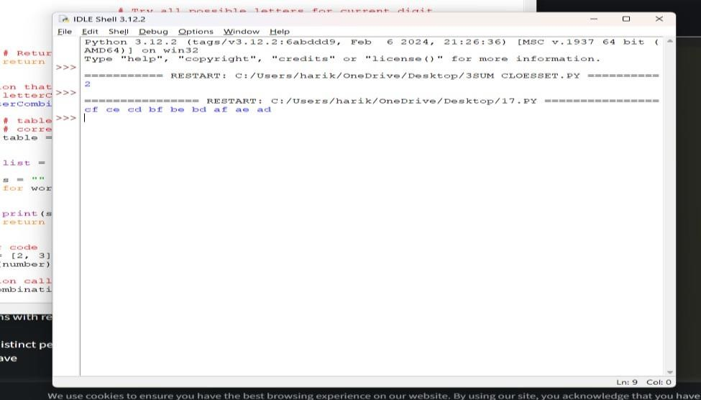

# 18. 4Sum

Given an array nums of n integers, return *an array of all the unique quadruplets*

[nums[a], nums[b], nums[c], nums[d]] such that: ● 0 <= a, b, c, d < n

* a, b, c, and d are distinct.
* nums[a] + nums[b] + nums[c] + nums[d] == target

CODE:

Pair:

def init (self, x, y):

self.index1 = x self.index2= y

def GetQuadruplets(nums, target):

map = {}

for the map for i in range(len(nums) - 1):

for j in range(i + 1, len(nums)): # Find the sum of pairs of elements sum = nums[i] + nums[j]

if sum not in map:

map[sum] = [Pair(i, j)]

else: map[sum].append(Pair(i, j))

ans = set()

for i in range(len(nums) - 1): for j in range(i + 1, len(nums)): lookUp = target - (nums[i] + nums[j])

if lookUp in map:

temp = map[lookUp]

for pair in temp:

if pair.index1 != i and pair.index1 != j and pair.index2 != i and pair.index2 != j: l1 = [nums[pair.index1], nums[pair.index2], nums[i], nums[j]]

l1.sort()

ans.add(tuple(l1))

print(*reversed(list(ans)), sep = '\n')

arr = [1, 0, -1, 0, -2, 2]

K = 0

GetQuadruplets(arr, K)

OUTPUT:

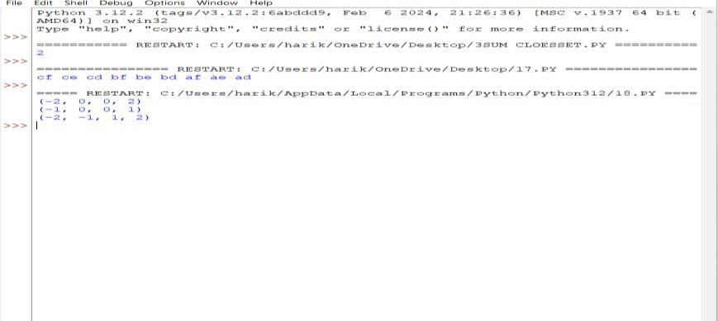

19. Remove Nth Node From End of List

Given the head of a linked list, remove the nth node from the end of the list and return its head.

CODE:

class Node:

def init (self, value):

self.data = value self.next = None def length(head): temp = head count = 0 while(temp != None): count += 1 temp = temp.next return count

def printList(head): ptr = head while(ptr != None): print (ptr.data, end =" ") ptr = ptr.next print()

def deleteNthNodeFromEnd(head, n): Length = length(head) nodeFromBeginning = Length - n + 1 prev = None temp = head for i in range(1, nodeFromBeginning):

prev = temp temp = temp.next if(prev == None): head = head.next return head else: prev.next = prev.next.next return head

if name == ' main ':

head = Node(1) head.next = Node(2) head.next.next = Node(3) head.next.next.next = Node(4) head.next.next.next.next = Node(5) print("Linked List before Deletion:") printList(head)

head = deleteNthNodeFromEnd(head, 4)

print("Linked List after Deletion:") printList(head)

OUTPUT:

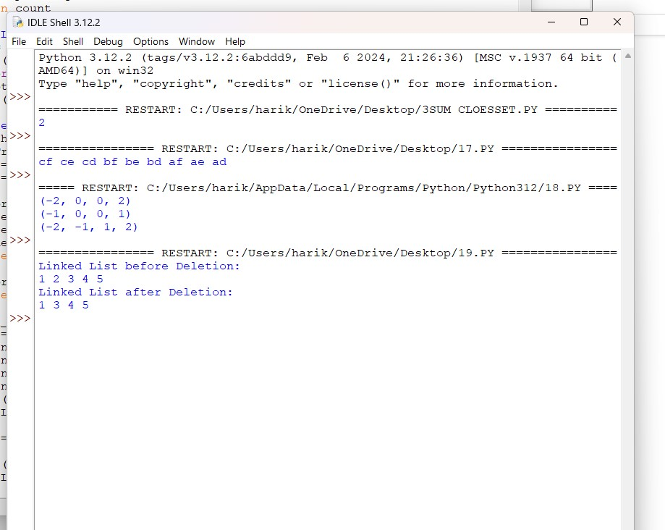

# 20. Valid Parentheses

Given a string s containing just the characters '(', ')', '{', '}', '[' and ']', determine if the input string is valid.

An input string is valid if:

1. Open brackets must be closed by the same type of brackets.
2. Open brackets must be closed in the correct order.
3. Every close bracket has a corresponding open bracket of the same type.

CODE: def areBracketsBalanced(expr): stack = []

For char in expr:

if char in ["(", "{", "["]: # Push the element in the stack stack.append(char) else:

if not stack:

return False

current_char = stack.pop() if current_char == '(':

if char != ")":

return False

if current_char == '{':

if char != "}":

return False

if current_char == '[':

if char != "]":

return False if stack:

return False return True

if name == " main ":

expr = "{()}[]"

if BracketsBalanced(expr): print("Balanced")

else:

print("Not Balanced")

OUTPUT:

